1. **Which are the top three variables in your model which contribute most towards the probability of a lead getting converted?**

Ans.

Based on the coefficient values in the model, the top three variables that contribute the most towards the probability of a lead getting converted are:

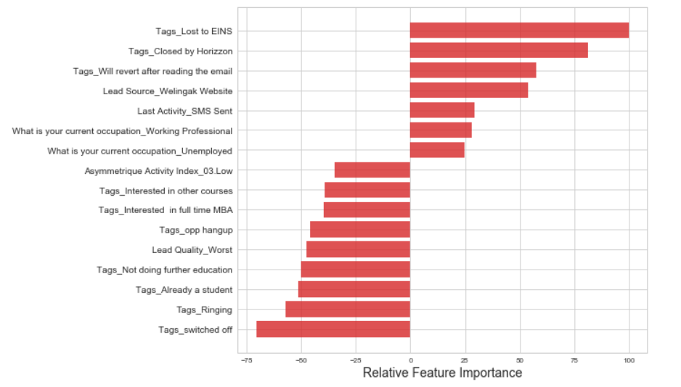

1. **Tags_Lost to EINS**
2. **Tags_Closed by Horizzon**
3. **Tags_Will revert after reading the email**

These variables have the highest positive coefficients, indicating a strong positive influence on the conversion probability.

1. **What are the top 3 categorical/dummy variables in the model which should be focused the most on in order to increase the probability of lead conversion?**

Ans.

It appears that the top three categorical/dummy variables in the model that receive the maximum focus in order to increase the probability of lead conversion are:

1. **Tags_Lost to EINS**
2. **Tags_Closed by Horizzon**
3. **Tags_Will revert after reading the email**

These variables have been identified as the most influential in determining the likelihood of lead conversion. By giving them maximum focus, one can potentially enhance the chances of converting leads into customers

1. **X Education has a period of 2 months every year during which they hire some interns. The sales team, in particular, has around 10 interns allotted to them. So during this phase, they wish to make the lead conversion more aggressive. So they want almost all of the potential leads (i.e. the customers who have been predicted as 1 by the model) to be converted and hence, want to make phone calls to as much of such people as possible. Suggest a good strategy they should employ at this stage.**

Ans.

During the period when X Education hires interns and wants to make lead conversion more aggressive, they should focus on maximizing the sensitivity of the model. Sensitivity measures the proportion of actual conversions that are correctly predicted by the model.

By choosing a lower threshold value for the conversion probability, X Education can increase the sensitivity of the model. This means that the model will identify a higher percentage of leads who are likely to convert, allowing the sales team to target these leads with phone calls.

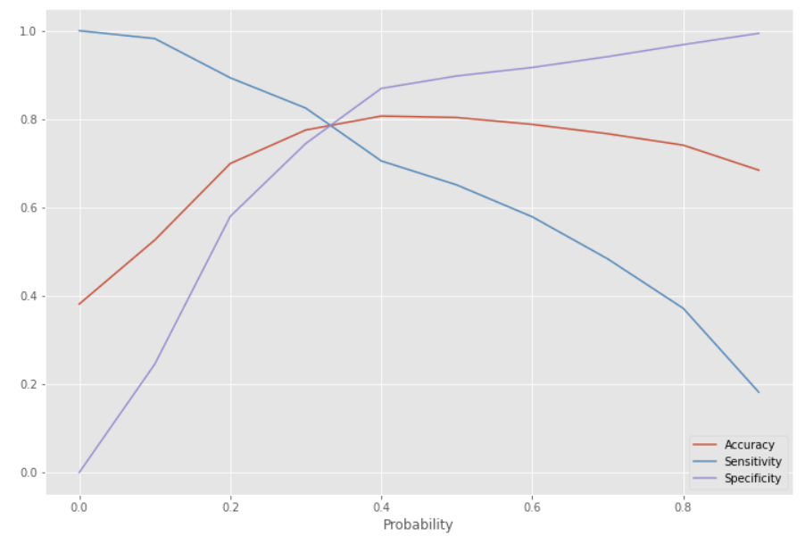

However, it's important to note that choosing a lower threshold may also result in a higher number of false positives, where non-converting leads are incorrectly classified as conversions. X Education should consider this trade-off and ensure that they have sufficient resources to handle the increased workload of contacting a larger pool of potential leads.

To summarize, X Education should employ a strategy of setting a lower threshold for the conversion probability to maximize the sensitivity of the model during the period of aggressive lead conversion. This will allow them to identify and target as many potential leads for conversion as possible, utilizing the available resources of the interns effectively.

1. **Similarly, at times, the company reaches its target for a quarter before the deadline. During this time, the company wants the sales team to focus on some new work as well. So during this time, the company’s aim is to not make phone calls unless it’s extremely necessary, i.e. they want to minimize the rate of useless phone calls. Suggest a strategy they should employ at this stage.**

Ans.

During the period when X Education has already reached its target for a quarter and wants to minimize the rate of useless phone calls, they should focus on maximizing the specificity of the model. Specificity measures the proportion of actual non-conversions that are correctly predicted by the model.

By choosing a higher threshold value for the conversion probability, X Education can increase the specificity of the model. This means that the model will accurately identify a higher percentage of leads who are not likely to convert, reducing the number of unnecessary phone calls.

However, it's important to consider that choosing a higher threshold may also result in a higher number of false negatives, where actual conversions are incorrectly classified as non-conversions. X Education should carefully assess this trade-off and ensure that they have alternative strategies in place to capture potential leads who may still be interested despite not meeting the higher conversion probability threshold.

To summarize, during the period when X Education has already reached its target for a quarter and wants to minimize useless phone calls, they should employ a strategy of setting a higher threshold for the conversion probability to maximize the specificity of the model. This will help them avoid making unnecessary phone calls and allow the sales team to focus on new work or other productive activities.